12.Deployment of Static Website using GitHub Pages

Aim:
To design a static website using HTML, CSS, and JavaScript and deploy it globally using the GitHub Pages hosting service.

Procedure / Algorithm:
- Project Creation: Create a local folder on the computer and develop the core web files: index.html (structure), style.css (design), and script.js (functionality).
- GitHub Repository Setup: Log in to GitHub and create a new public repository named username.github.io (where username is your GitHub handle).
- Local Initialization: Open the terminal/command prompt, navigate to the project folder using the cd command, and initialize a Git repository using git init.
- Connecting to Remote: Link the local folder to the GitHub repository using git remote add origin [URL].
- Staging and Committing: Stage all files using git add . and commit the changes with a descriptive message using git commit -m.
- Deployment: Push the code to the main branch using git push -u origin main.
- Verification: Navigate to the repository settings, ensure GitHub Pages is enabled for the main branch, and visit the live URL.

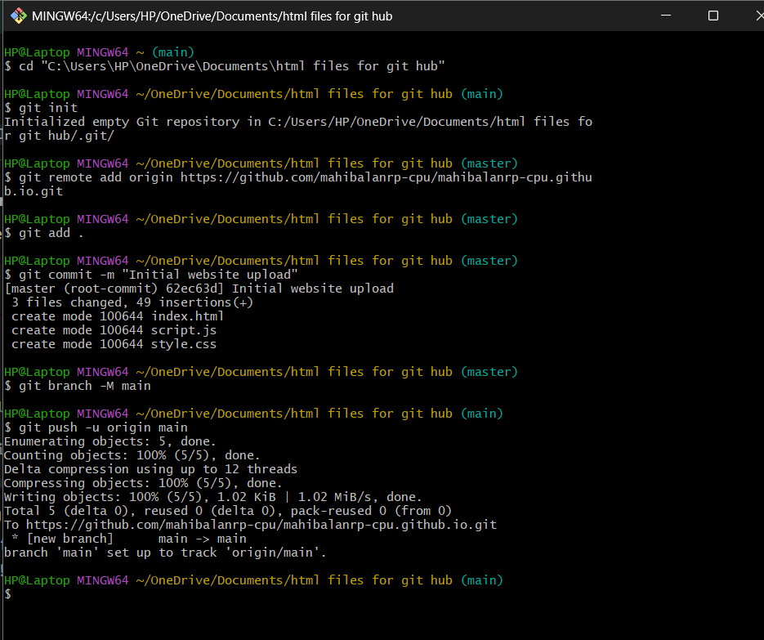
Code and Output:

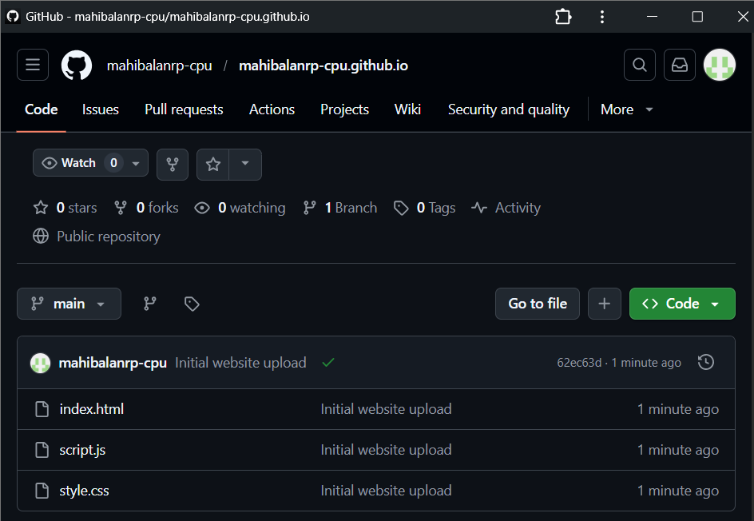

Result:
The static website was successfully designed, developed, and deployed using GitHub Pages. The website is now accessible globally via the URL: https://mahibalanrp-cpu.github.io.

